Software Design Fundamentals - Architecture
# Source: AI Source: Provided by: [Data Path: Persons Table -> ID Column: 1, Name_En Column: Motasem Essam] -> From: [ChatGPT] on [1/23/2026]
Architecture is the high-level structure of a software system. It defines how components, modules, and layers are organized and how they interact with each other.
👉 Think of architecture as the skeleton or blueprint of your software.

🔑 Key Points
# Source: AI Source: Provided by: [Data Path: Persons Table -> ID Column: 1, Name_En Column: Motasem Essam] -> From: [ChatGPT] on [1/23/2026]
- Defines overall system structure
- Specifies components/modules and their responsibilities
- Shows relationships and interactions
- Determines technology stack and patterns
- Ensures scalability, maintainability, and reliability

🧱 Types of Software Architecture style
# Source: AI Source: Provided by: [Data Path: Persons Table -> ID Column: 1, Name_En Column: Motasem Essam] -> From: [ChatGPT] on [1/23/2026]
- Monolithic Architecture
  - All components are in a single codebase
  - Simple to develop and deploy for small projects
  - Example: App with Controller, Service, Repository all in one deployable unit
- Layered Architecture
  - Commonly used in enterprise apps
  - Layers: Presentation → Business → Data
  - Example: Controller → Service → Repository
- Client-Server Architecture
  - Separates client (frontend) and server (backend)
  - Example: Web app with React frontend and Java backend
- Microservices Architecture
  - System divided into independent services
  - Each service handles a specific domain
  - Communicates via APIs
- Event-Driven Architecture
  - Components communicate through events
  - Useful for real-time systems
- Service-Oriented Architecture (SOA)
  - Similar to microservices but often larger, enterprise-level services

❌ Bad Example (No Architecture)
# Source: AI Source: Provided by: [Data Path: Persons Table -> ID Column: 1, Name_En Column: Motasem Essam] -> From: [ChatGPT] on [1/23/2026]
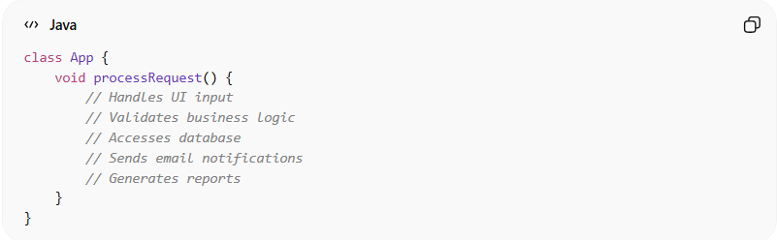
class App {
void process() {
// validation
// database access
// business logic
// send emails
}
}
👉 Problems:
- Everything in one class
- No separation of concerns
- Hard to scale or maintain

✅ Good Example (Layered Architecture)
# Source: AI Source: Provided by: [Data Path: Persons Table -> ID Column: 1, Name_En Column: Motasem Essam] -> From: [ChatGPT] on [1/23/2026]
Client → UserController → UserService → UserRepository → Database
Class Responsibilities:
- UserController → Handles requests
- UserService → Business logic
- UserRepository → Database operations

💡 Key Idea
# Source: AI Source: Provided by: [Data Path: Persons Table -> ID Column: 1, Name_En Column: Motasem Essam] -> From: [ChatGPT] on [1/23/2026]
Architecture defines how the system is structured, which modules exist, and how they communicate, before writing code.

